PIZZA SALES SQL QUERIES
- KPI’s
- Total Revenue
select sum(total_price) as Total_Revenue from pizza_sales

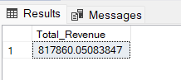

- Average Order Value
select sum(total_price)/count (distinct order_id) as Avg_Order_Value from pizza_sales

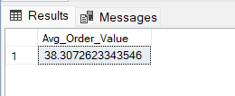

- Total Pizza Sold
select sum(quantity) as Total_Pizzas_Sold from pizza_sales

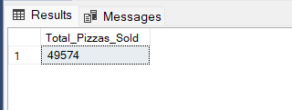

- Total Orders
select count(distinct order_id) as Total_orders from pizza_sales

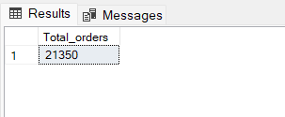
- Average Pizzas Per Order
select cast(cast(sum(quantity) as decimal(10,2)) /
cast(count(distinct order_id) as decimal(10,2)) as decimal(10,2)) as Avg_Pizzas_Per_Order from pizza_sales

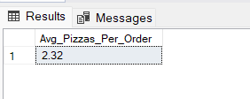

- Daily Trend For Total Orders

select datename(DW, order_date) as order_day, count(distinct order_id) as Total_orders
from pizza_sales
group by datename(DW, order_date)

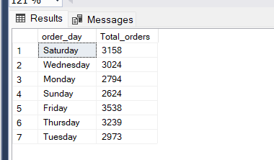

- Hourly Trend For Total Orders
select datename(month, order_date) as Month_Name, count(distinct order_id) as Total_Orders
from pizza_sales
group by datename(month, order_date)
order by Total_Orders desc

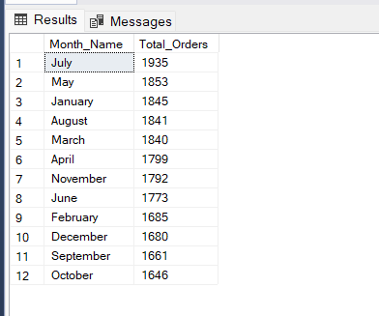

- Percentage Of Sales By Pizza Category

select pizza_category, sum(total_price) as T Total_Sales,sum(total_price) * 100 /
(select sum(total_price) from pizza_sales where month(order_date) = 1) as PCT
from pizza_sales
where month(order_date) = 1
group by pizza_category

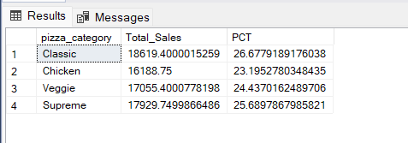

9.Total Pizzas Sold by Pizza Category

select pizza_size, cast(sum(total_price) as decimal(10,2)) as Total_Sales,cast(sum(total_price) * 100 /
(select sum(total_price) from pizza_sales where datepart(QUARTER,order_date) = 1) as decimal(10,2)) as PCT
from pizza_sales
where datepart(QUARTER,order_date) = 1
group by pizza_size
order by PCT desc

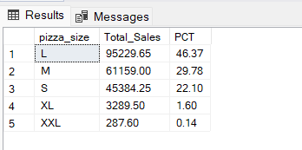

10.Top 5 Best Sellers by Revenue, Total Quantity and Total Orders

select top 5 pizza_name, sum(total_price) as Total_Revenue from pizza_sales
group by pizza_name
order by Total_Revenue desc

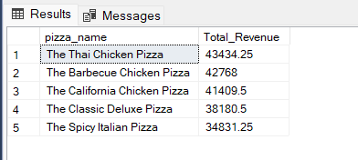

11. Bottom 5 Pizzas by Revenue

select top 5 pizza_name, sum(total_price) as Total_Revenue from pizza_sales
group by pizza_name
order by Total_Revenue

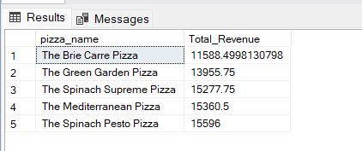

12.

